Git Documentation for Presentation
- git init Initialise the empty Github Repository

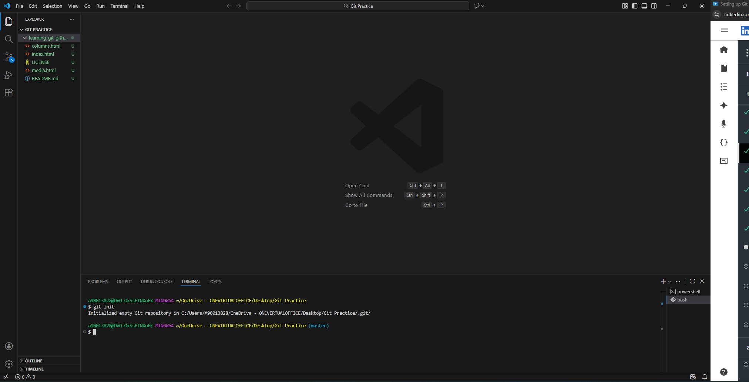

- git config –-global user.name [name] set name
- git config –-global user.email [email] set email

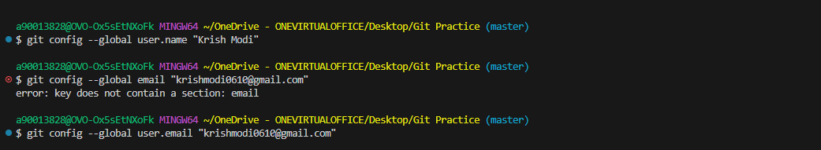

- git add [Filename ] Staging Files
git add . Staging all files
git add -A Staging all the files at once

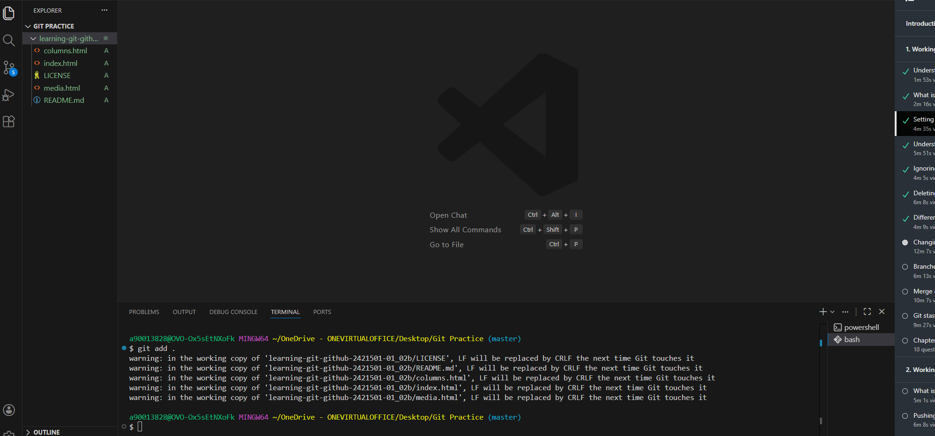

- git commit -m [message] Commit/ Checkpoint creation

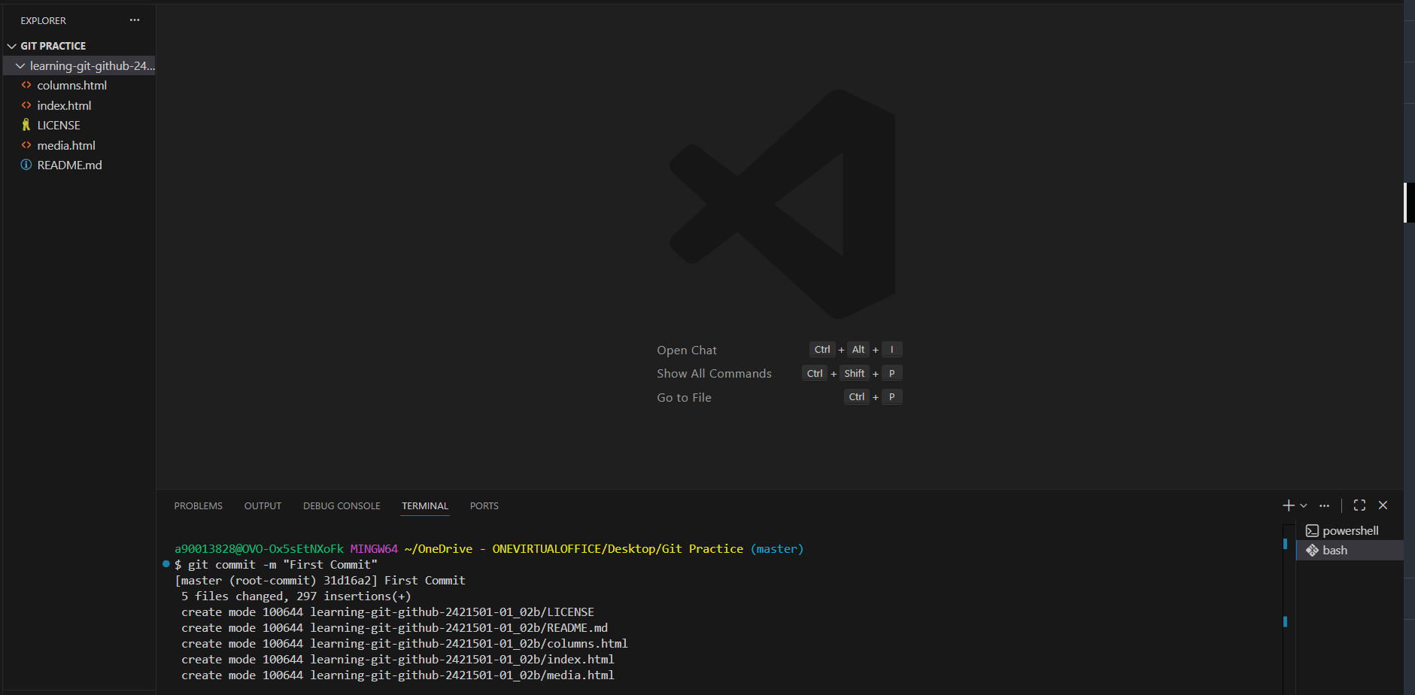
- git log Getting all the information of commits
git log –oneline Get logs in one line
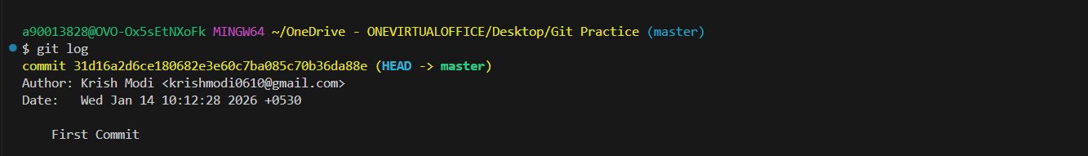

- git status To check the current git status

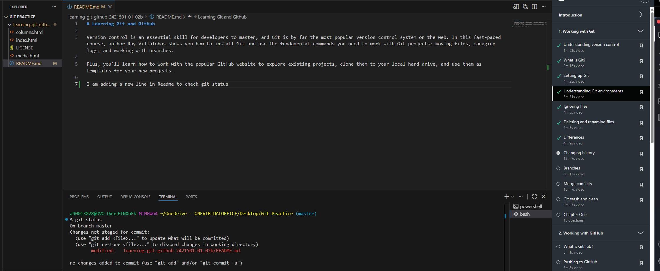

- git restore [File Name] Restore back untracked files
git restore –-staged [File Name] Unstage the file
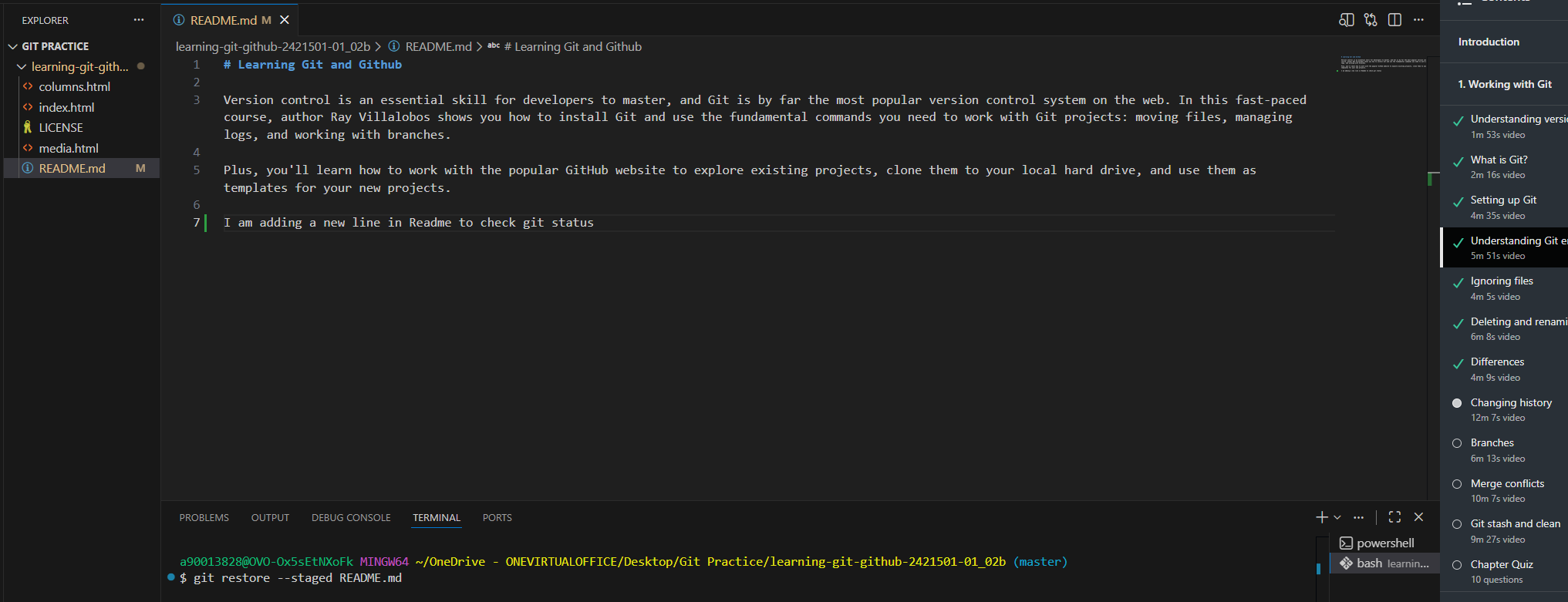
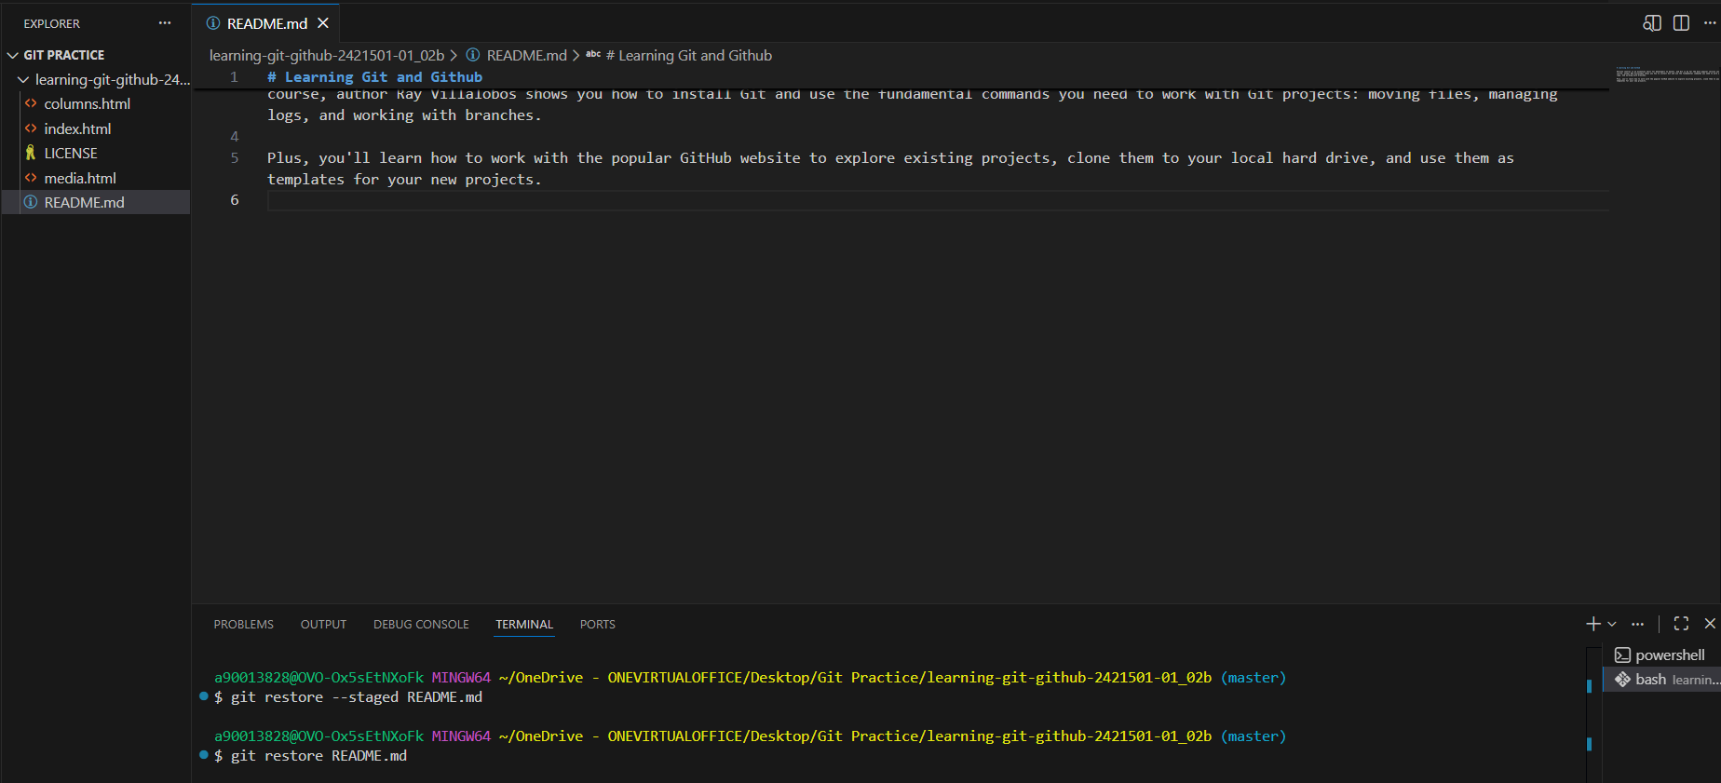
- .gitignore Files/Folders that needs to be ignored in git commits
- git rm -f [filename] Delete a file
- git mv [old_file] [new_file] Rename a file
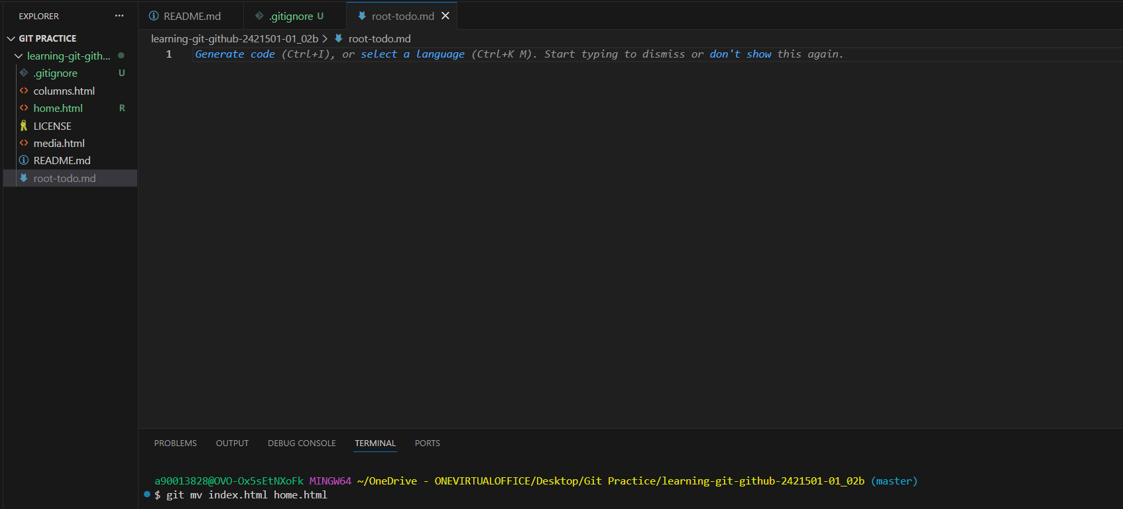
- git diff Show differences between last committed file and changes after that
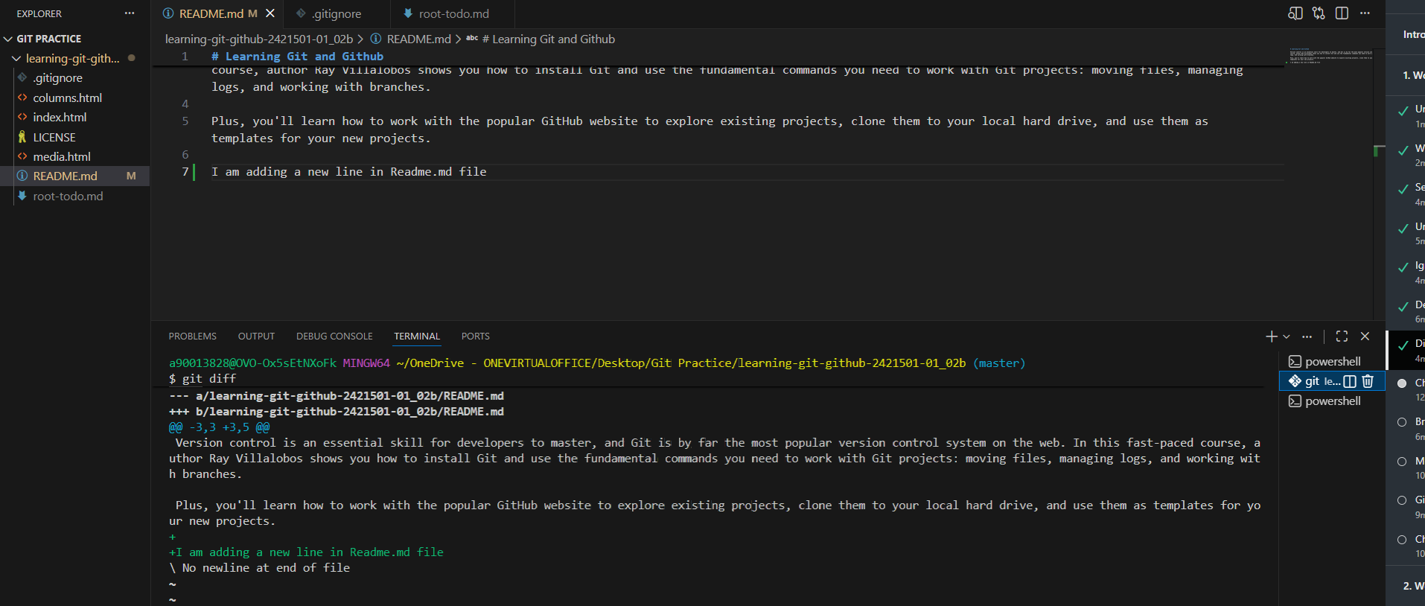

- git commit –-amend Rename the commit messages
git commit –-amend -m “New message”
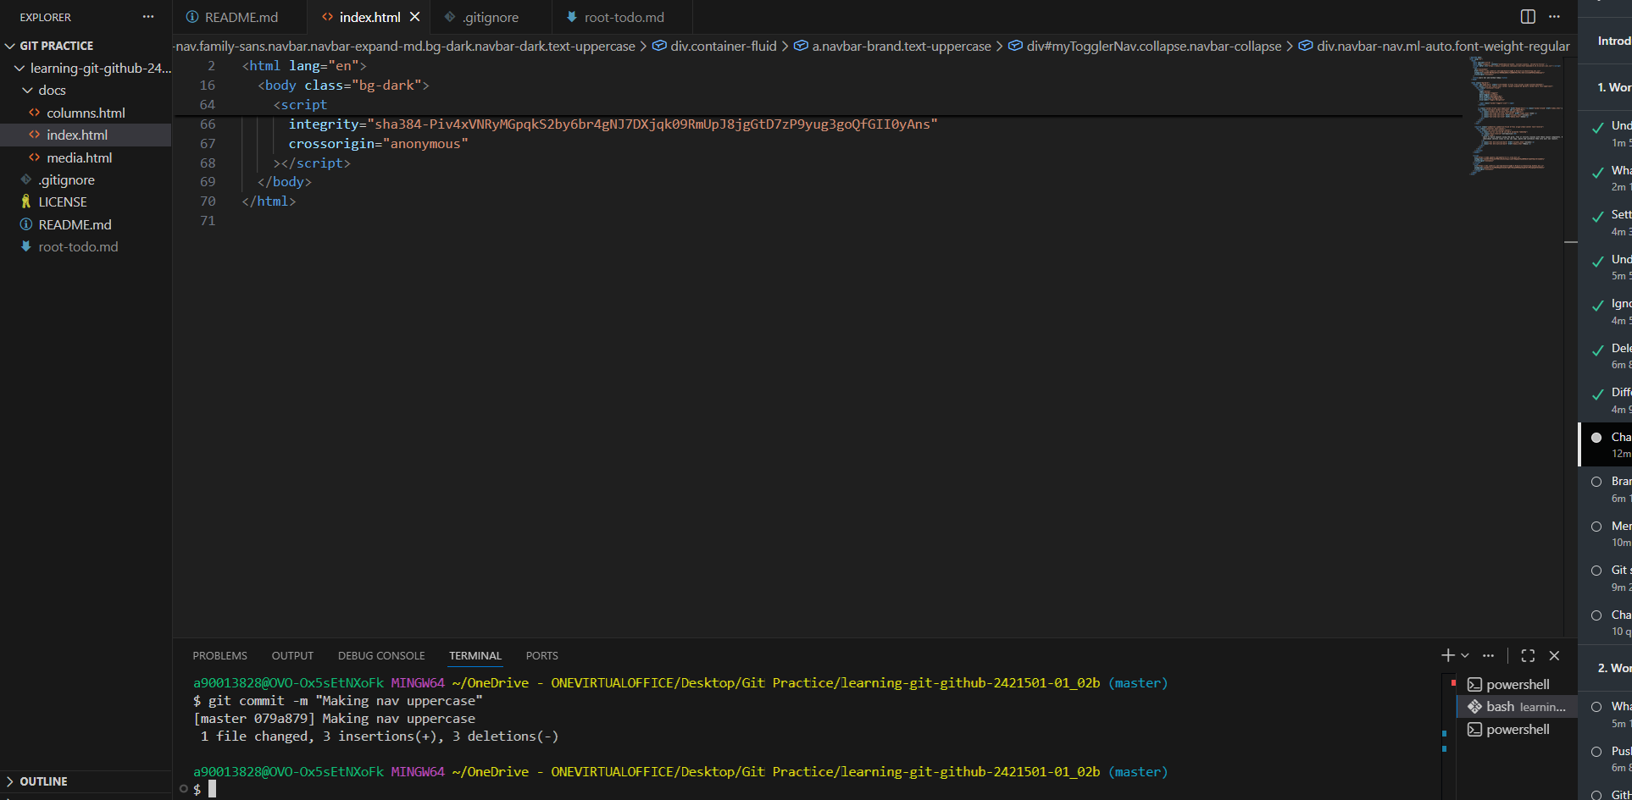

- git reset [commit hash] Undoing the changes back to the hash commit

- git rebase <commit>/<branch> Re-organising commits 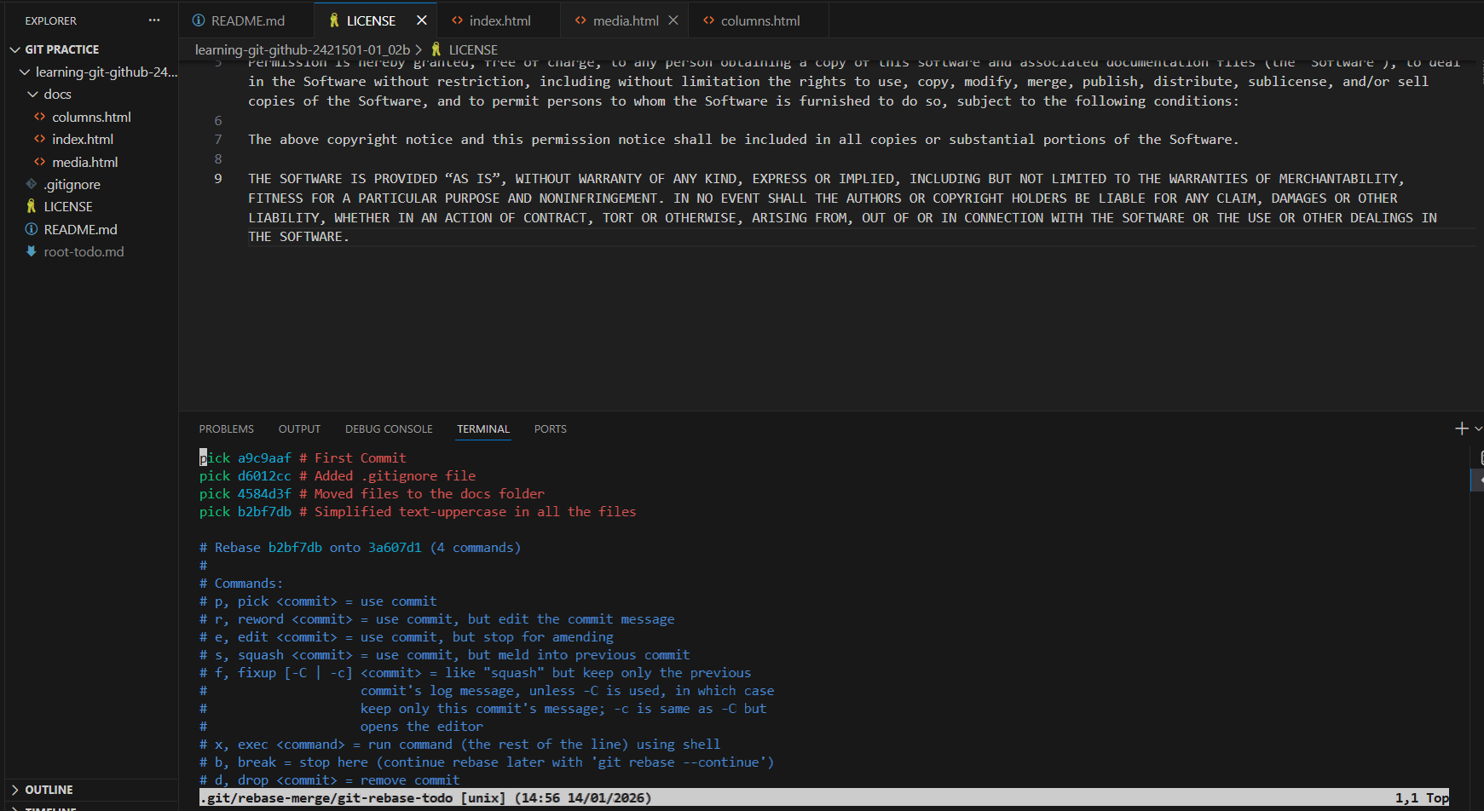

- git branch Get the list of all the branches in the git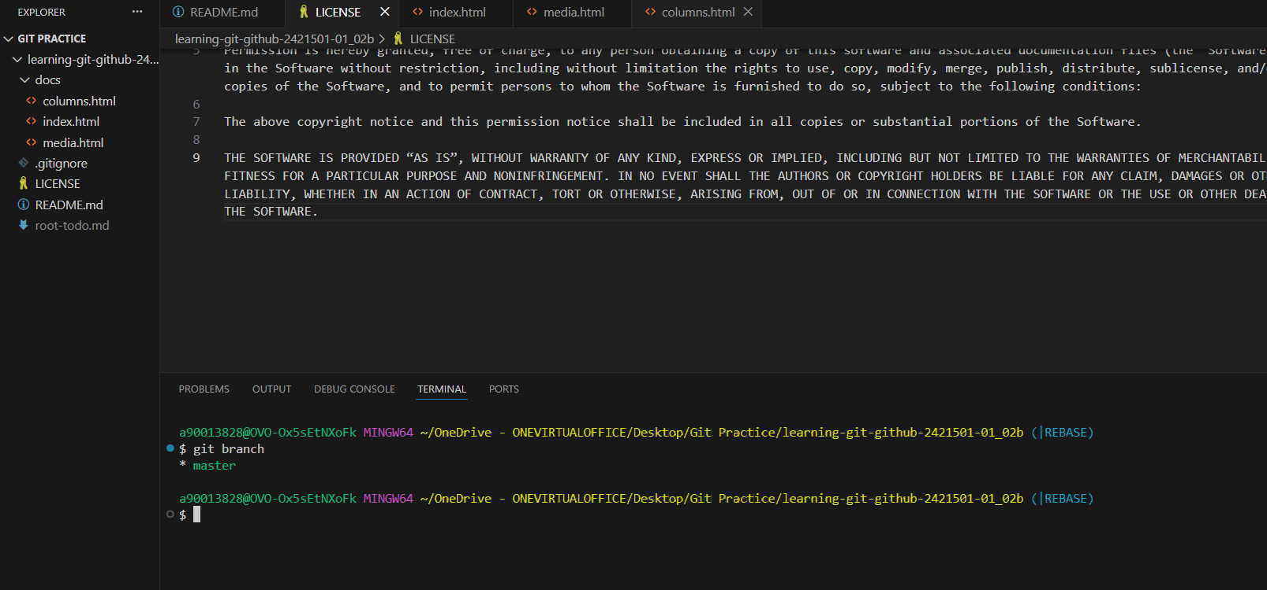

- git switch -c [Name] Create and Switch the branch in git

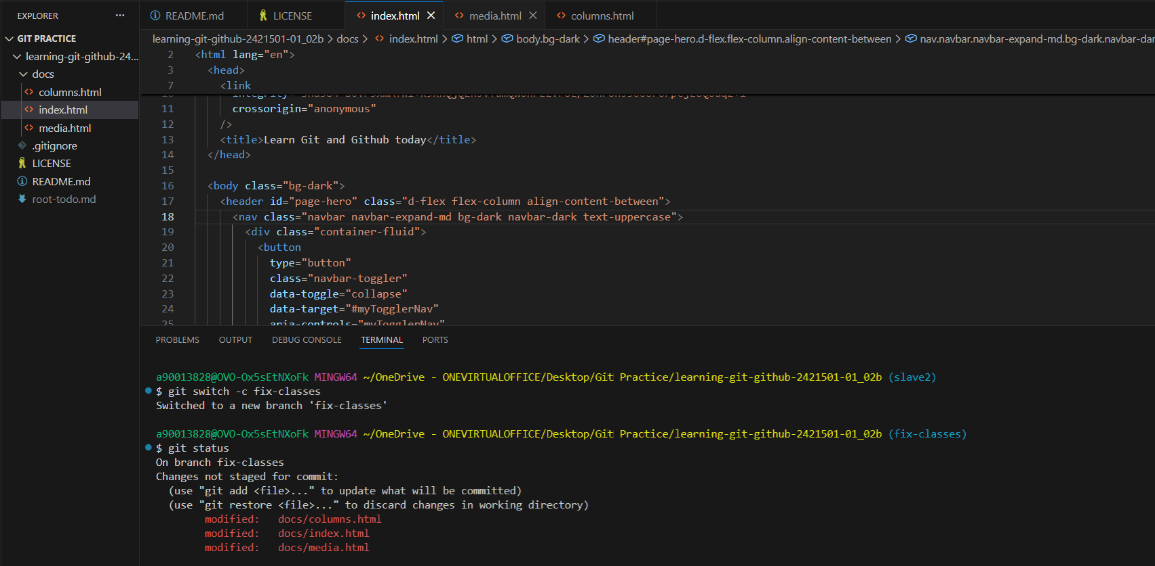

- git merge [branch-name] merge master with branch

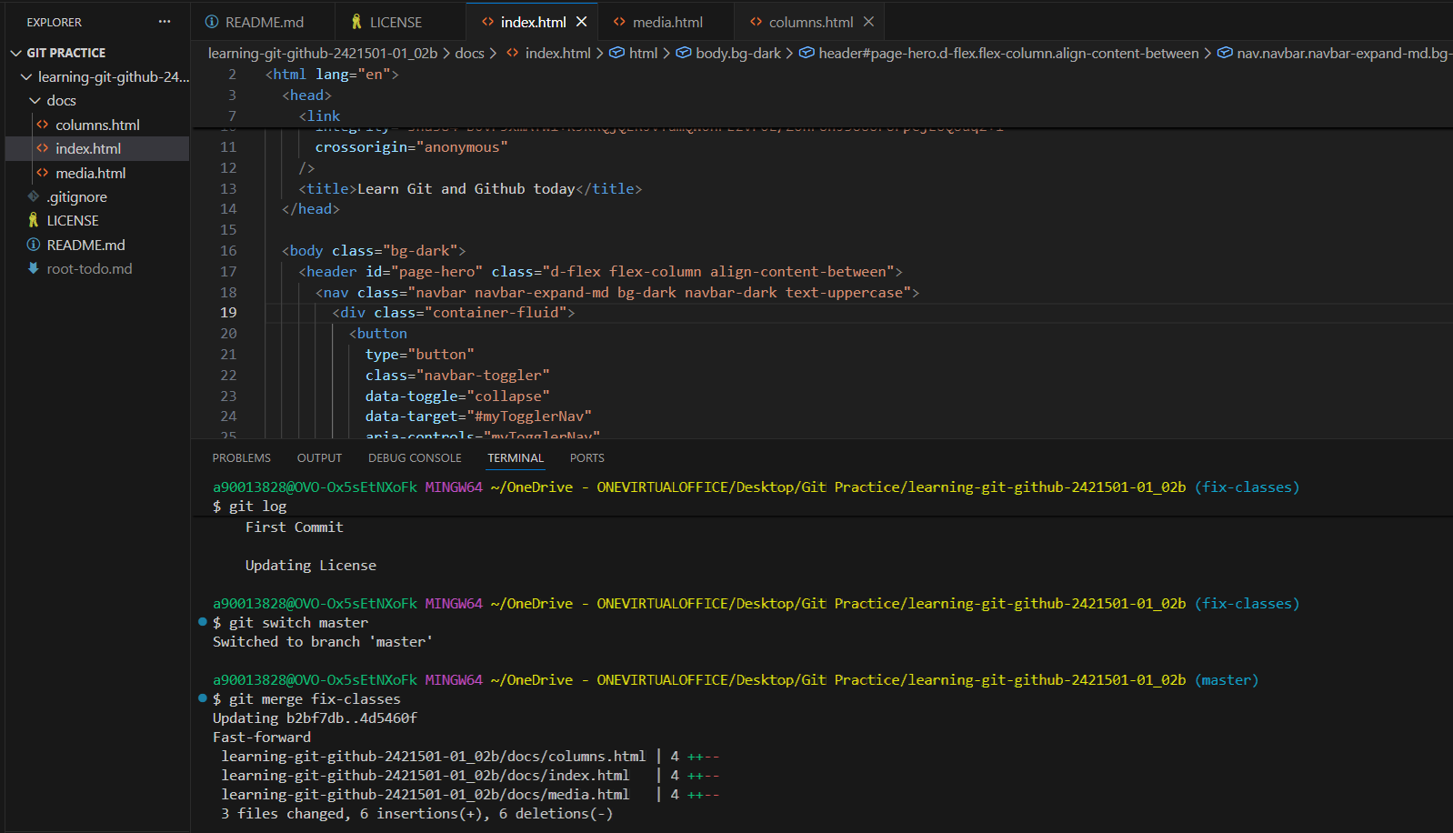

- git branch -d [branch_name] Delete a branch
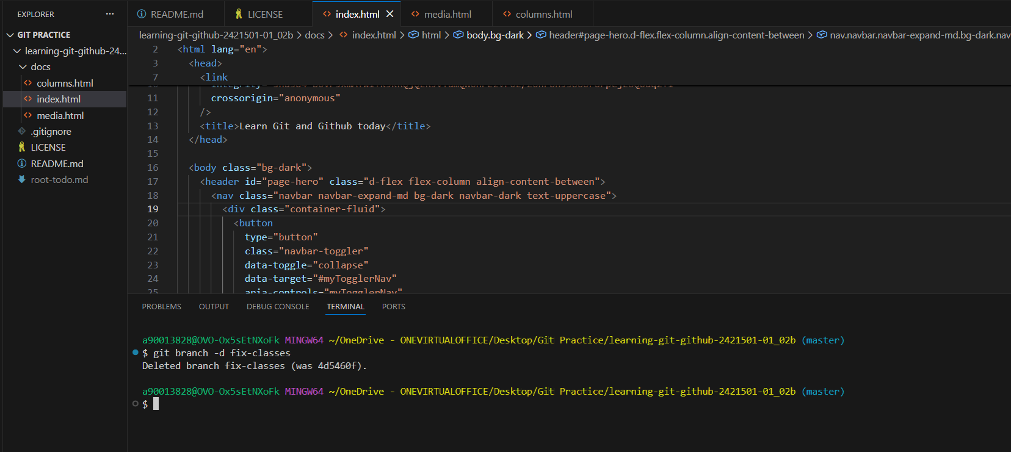

- Merge Conflict Occuring A scenario where merge conflict occurs
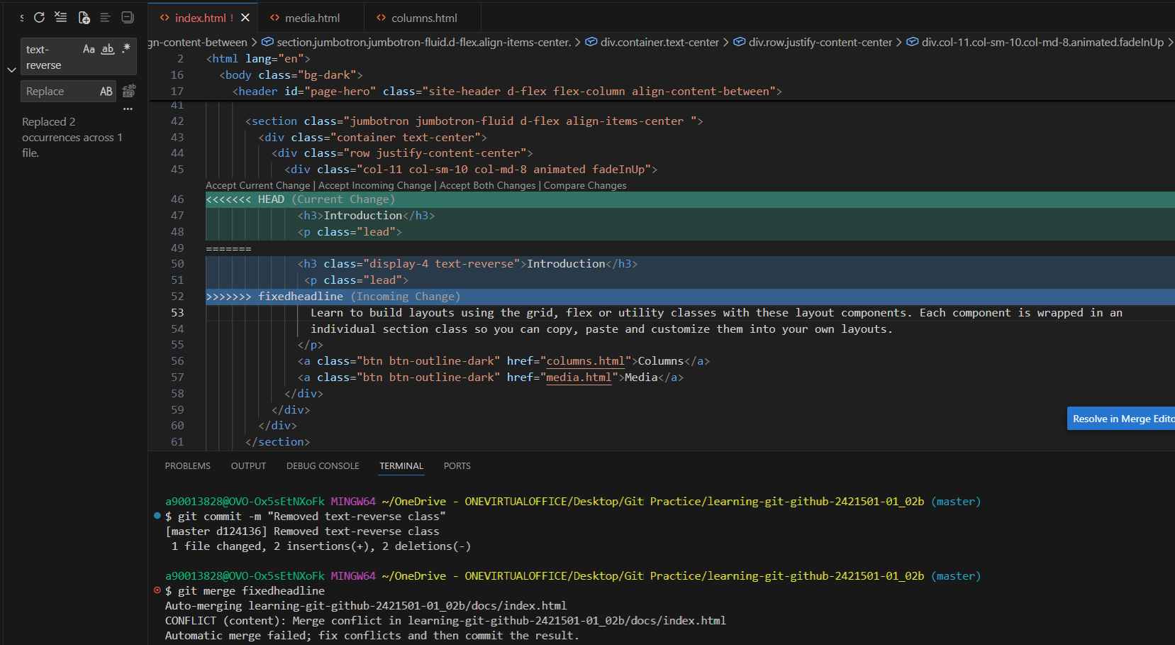

- Stashing Git
Git stash Temporarily store the current changes made
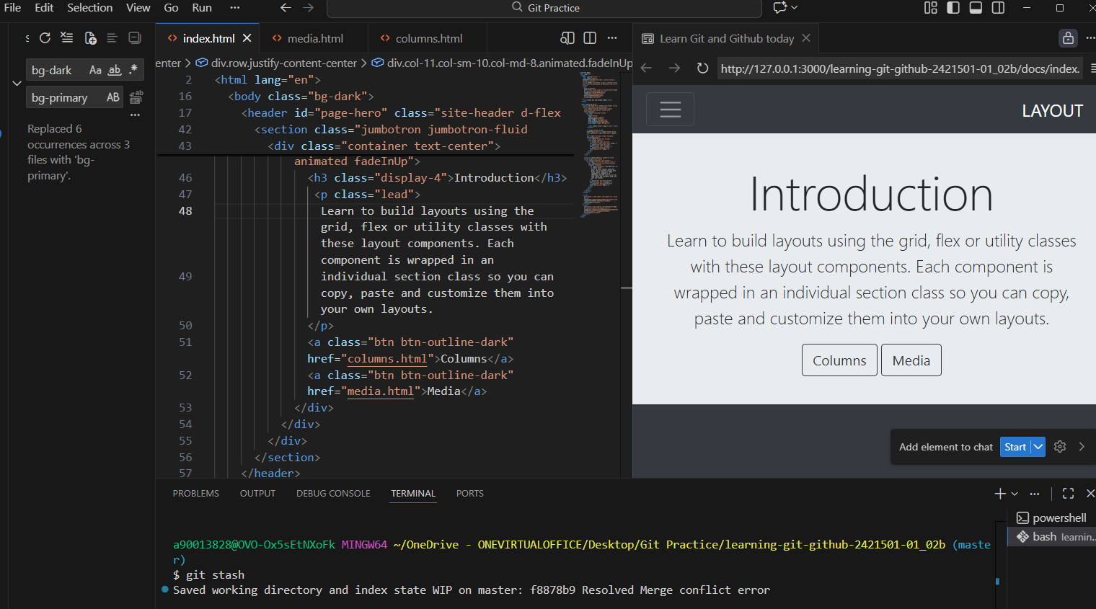

git stash list List down all the stash

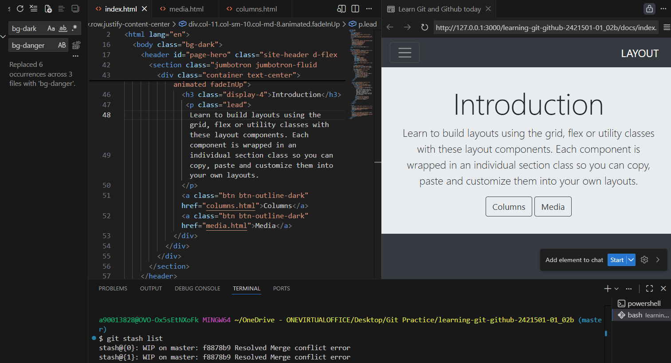

git stash pop Removes the last stash from the list

git stash apply [index] Apply the specified index stash
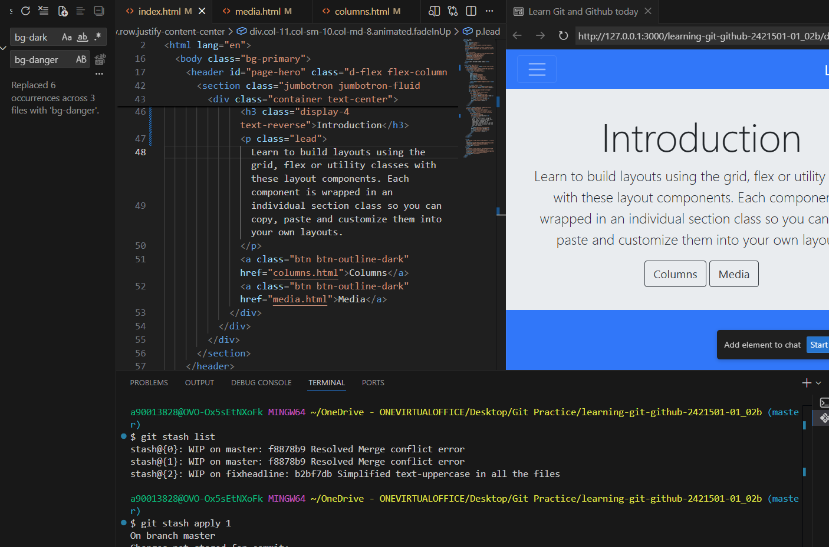

- Cleaning in git
git clean Allows to remove untracked files and directories from your branch super quickly.

git clean -n dry run
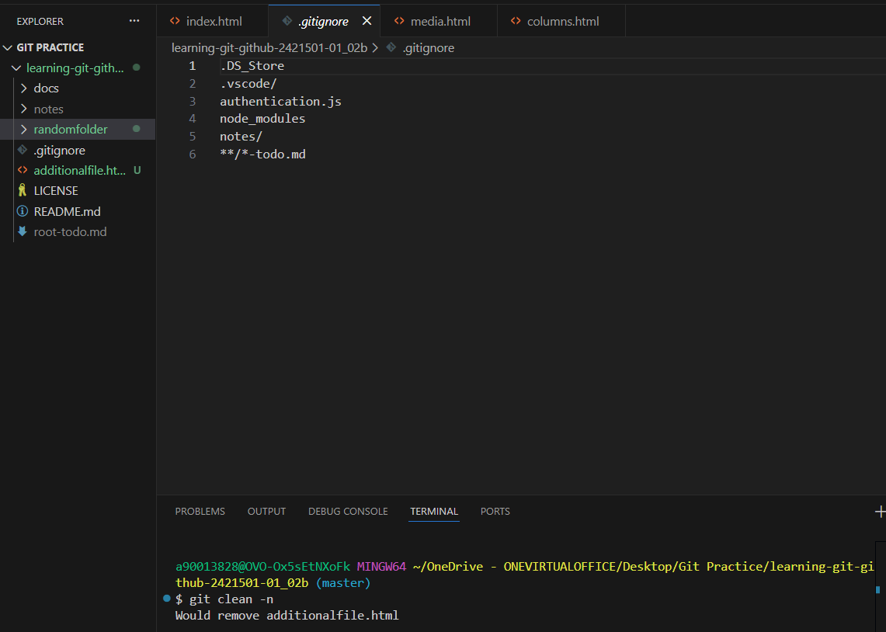

git clean -d directories
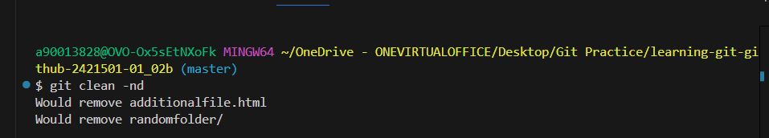

git clean -f force
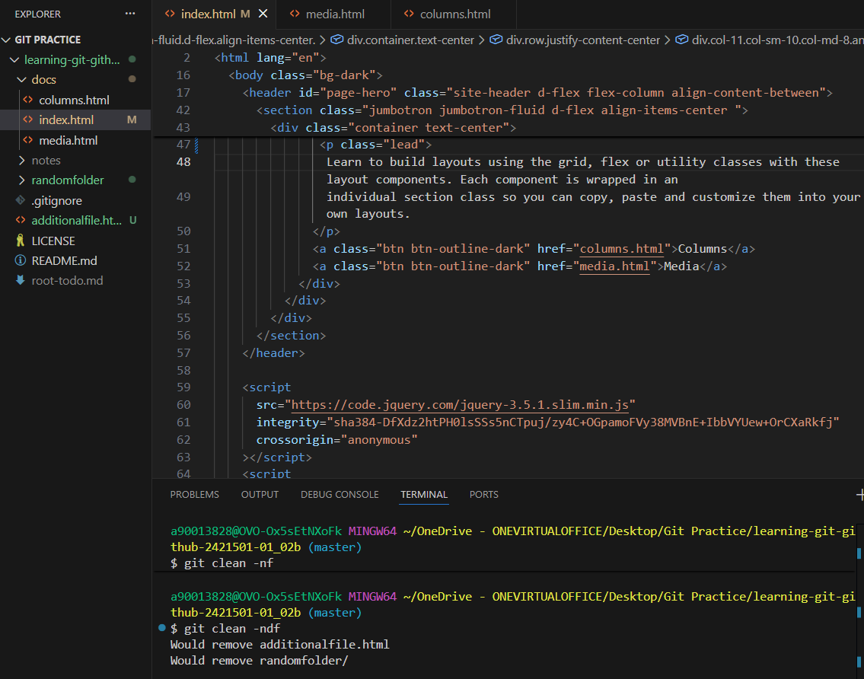

- Git remote add <name> <url> Adding a new repository
  - Git remote -v verifying the remote repository
  - Git remote rm <name> delete a repository
  - Git remote rename [old] [new] Rename a remote repository
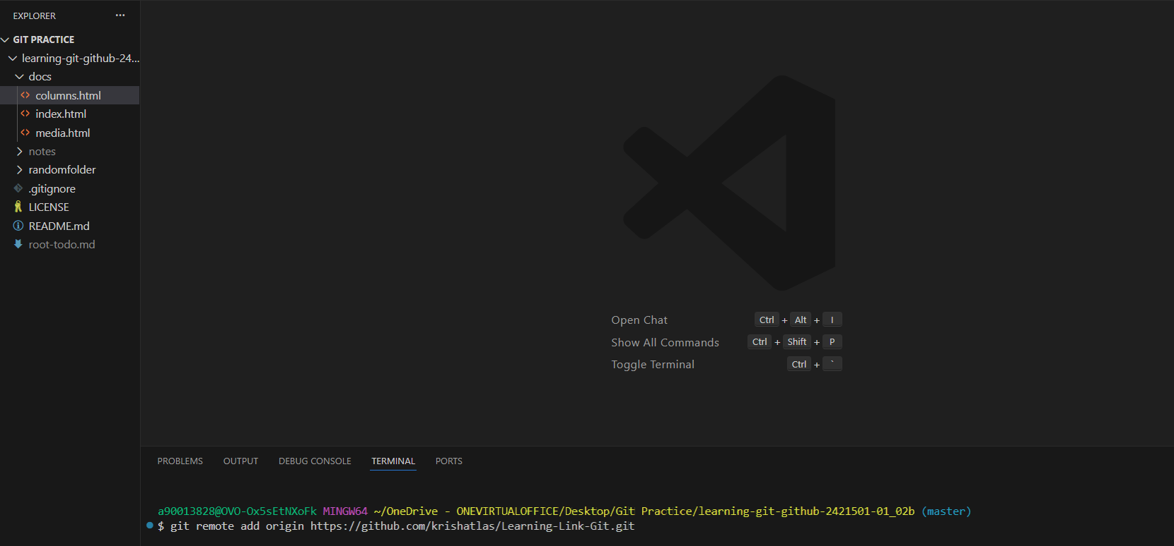
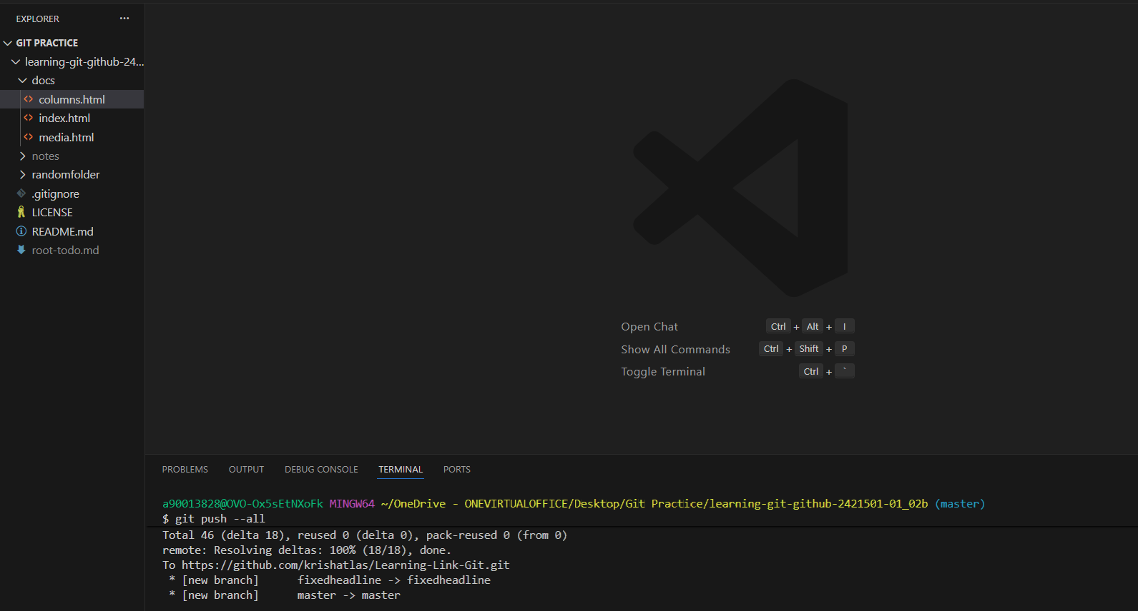

- Git clone Cloning the remote repository
- Git Fetch
- Git Pull Bring all the changes from github to locally and 